FALL AND EDGE PROTECTION

PROCEDURES AND GUIDELINES
FOR
THE CITY OF NEWTON
P.O. Box 550
Newton, NC 28658

Written in accordance with
OSHA Code of Federal Regulations
1910.23 & 1926.500

Effective Date:

04/01/11

Developed By:
Compliance Training Associates, Inc.
P.O. Box 669842
Charlotte, NC 28266-9842
Phone # - 704/735-3636
Fall/Edge Protection Practices

Purpose: Per OSHA 1910.23, fall protection must be provided for employees who are exposed to walking/working surfaces which are four (4) or more feet above the ground. In an effort to protect our workers from fall hazards, the following fall prevention policy has been adopted.

Policy: When engineering or administrative controls will not provide an acceptable level of protection, protective equipment shall be provided to achieve safe working conditions. When fall protection equipment is necessary, the requirements of the Fall Protection Standard (1926.500 – Subpart M) shall be followed.

Engineering Controls: When feasible, all operations from which there is a drop of more than four (4) feet shall be guarded by a rail, fence, half door or equivalent barrier. Barrier design criteria are established in OSHA 1910.23. Where barriers are not feasible for work at elevated heights (greater than 4 feet), fall protection equipment or policy must be used per OSHA General Industry Standards. Suitable anchorage points shall be utilized.

Personal Protective Equipment: Personal Protective Equipment (PPE) requirements for fall protection vary depending upon the task being conducted. If tasks are not identified below, the individual required to work at an elevated height shall receive instructions from their Supervisor prior to proceeding.

Elevated Work Platforms/Aerial Lifts: Elevated work platforms used by the City of Newton are equipped with rails to provide edge protection. In addition, each worker must be protected by a safety harness attached to a shock absorbing lanyard. The lanyard shall be securely attached to the anchor point of the platform approved by the manufacturer. The lanyard should safely suspend the worker in event of a fall and shall ensure the worker can fall no more than six (6) feet. Fall protection equipment must meet design criteria specified in Appendix C, Section 1 of OSHA 1910.66. Employees must also keep feet flat on the floor of the lift.

Flat Roofs: For work such as checking for roof leaks, minor repair of roof leaks and clearing roof drains employees are required to stay 6 feet from the edge of the roof. If this task requires the employee to work in close proximity to the "6 foot from edge zone", the work will be conducted using a Safety Monitoring System. If a ladder is used to access the roof, the rungs of the ladder must extend three feet above the roof line/landing in order for an employee to safely access and dismount the roof.

Confined Spaces: Each worker entering a confined space shall be protected by a full body harness, life line and winch capable of retrieving personnel from vertical entries. Additional information regarding fall protection in Permit Required Confined Spaces in included in the City of Newton’s Confined Space Entry Program.

(1)
Safety Monitoring System: When a Safety Monitoring System is used such as for temporary roof work, the Safety Monitor will be on the same walking/working surface as the workers and will comply with the following requirements:

*The Safety Monitor shall be competent to recognize fall hazards.

*The Safety Monitor shall warn the employee when it appears that the employee is unaware of a fall hazard or is acting in an unsafe manner.

*The Safety Monitor shall be close enough to communicate orally with the employees.

*The Safety Monitor shall not have other responsibilities which could take the monitor's attention from the monitoring function.

Roof top HVAC work can be safely performed when the employee stays in close proximity to the unit. In some cases, roof hatches are located near the center of the roof. HVAC systems are located in close proximity to the hatches eliminating the need to approach the roof edge. If a ladder is used to access the roof top unit, the rungs of the ladder must extend three feet above the roof line/landing in order for an employee to safely access and dismount the roof.

If ladders are used to perform the task of gutter cleaning, no over-extending (over-reaching) is allowed.

Tasks such as changing overhead light bulbs located in tall ceilings not accessible by ladders will be performed using scaffolding or an aerial lift. If scaffolding is used, a competent person must be available for monitoring the scaffolding system.

Tasks such as painting will be performed using ladders or via aerial lift when not accessible by ladders.

Bucket trucks will be used for tasks such as trimming branches from tall trees and distribution work. Employees will use safety harnesses and lanyards to prevent falls from the bucket. No over extending (over-reaching) from the bucket is allowed. In addition, boom and bucket load limits specified by the manufacturer shall not be exceeded.

Portable Ladder Use: Portable ladders are often used by City of Newton employees. The ladders must be inspected before each use to be certain rungs are in place and free from oil, dirt, grass, etc. Metal spreaders or locking devices must be in place and in use to hold the front and back sections in place when the ladder is being used. On potentially slippery surfaces, anti slip/safety shoe/foot components must be in correct position. When ladders are used to reach roofs or other high places, three feet of the ladder rails must extend above the landing.

(2)
If ladders are to be used near electrical lines where the employee or ladder could come in accidental contact with the lines, only ladders with nonconductive side rails will be used.

Ladders should be used on level stable surfaces only. They may not be used in doorways or high traffic areas without first barricading the area. The top and bottom of the ladder should be kept clear at all times.

Employees of the City of Newton will follow correct ladder procedures such as:

- Be certain ladder is properly set up (4:1) ratio - the heel of the ladder should be 1/4 the expected height away from the wall.
- Ensure that each rung of ladder is firmly attached and locking devices are in good working order.
- Face ladder when ascending or descending.
- Maintain three points of contact when ascending or descending.
- Both hands should be free to grasp ladder rungs therefore no tools may be carried up or down a ladder.
- No hopping or jumping off the ladder rungs or steps.
- Locking the leg into the ladder rungs is required if hands free work is performed.
- Anti slip/safety shoe/foot components (ladder feet) must be in correct position.

Portable Ladder Inspections: Ladder components must be inspected before each use to be certain rungs are in place and free from oil, dirt, grass, etc. Spreaders should be in place and fully operational. All warning and informational signage must be in place. Ladders should never be painted. Any ladder with damaged or missing components should be tagged out of service until properly repaired. Ladders stored on trucks and exposed to the elements (sun, rain, excessive temperature, etc.) should be inspected for excessive wear, cracks, splits or other damage. Damaged ladders should be reported to the employee’s Supervisor immediately.

Fire Department Ladder Inspections: Ladders utilized by the City of Newton Fire Department are inspected in accordance with NFPA 1500 regulations. The ladder inspections are conducted and certified by a third party.

Personal Fall Arrest Systems: Personal fall arrest systems and their use shall comply with the provisions of 1926.502(d). Effective January 01, 1998, body belts are not acceptable as part of a personal fall arrest system.

- Connectors shall be drop forged, pressed or formed steel or made of equivalent materials.
- Connectors shall have a corrosion-resistant finish and all surfaces and edges shall be smooth to prevent damage to interfacing parts of the system.
- Dee-rings and snap hooks shall have a minimum tensile strength of 5,000 pounds.

(3)
- Snap hooks shall be sized to be compatible with the member to which they are connected to prevent unintentional disengagement of the snap hook. Effective January 01, 1998, only locking type snap hooks shall be used.
- Lifelines shall be protected against being cut or abraded.
- Self retracting lifelines and lanyards which automatically limit free fall distance to 2 feet or less shall be capable of sustaining a minimum tensile load of 3,000 pounds applied to the device with the lifeline or lanyard in the fully extended position.
- Self retracting lifelines and lanyards which do not limit free fall distance to 2 feet or less, rip stitch lanyards and tearing and deforming lanyards shall be capable of sustaining a minimum tensile load of 5,000 pounds applied to the device with the lifeline or lanyard in the fully extended position.
- Ropes and straps (webbing) used in lanyards, lifelines and strength components of body harnesses shall be made from synthetic fibers.
- Anchorages used for attachment of personal fall arrest equipment must be capable of supporting at least 5,000 pounds per employee attached.
- The attachment point of a body harness shall be located in the center of the wearer’s back near shoulder level or above the wearer’s head.
- Personal fall arrest systems and their components shall be used only for employee protection, not for hoisting materials.
- Personal fall arrest systems and components subjected to impact loading shall be immediately removed from service and shall not be used again for employee protection until inspected and determined by a competent person to be undamaged and suitable for reuse.
- Personal fall arrest systems shall be inspected prior to each use for wear, damage and other deterioration. Defective components shall be removed from service.

Scaffolding Requirements: The City of Newton shall provide a competent person for each job task which requires scaffolding. The scaffolding shall be installed so as to ensure the following:

- Scaffolds and components must support four times the intended load.
- Scaffolds must be fully planked.
- Scaffold planks or mudsills must not be painted.
- No mixing of dissimilar components.
- Guardrails will be in place on all scaffolds over ten feet.

The City of Newton will be certain the competent person is capable of identifying existing and predictable hazards in the surroundings or working conditions which are unsanitary, hazardous or dangerous to employees, and has the authorization to take prompt corrective measures to eliminate them. The competent person will inspect the scaffolding during all processes such as erecting, disassembling, moving, operating, repairing and maintaining. The design criteria, maximum intended load-carrying capacity and intended use of the scaffolding will be checked frequently.

(4)
APPA & NEC Regulations: In addition to OSHA regulations, the Newton Electric Department utilizes APPA and NEC regulations as applied to fall protection including:

Fall arrest equipment shall be used on poles by qualified employees when such conditions as ice, high winds, design of structure (such as no hand holds) or the presence of contaminates exist that could cause the employee to lose his grip or footing.

A Bucksqueeze device shall be used for wood pole climbing. The device allows the employee to free climb the pole and is designed to prevent sudden quick movements/falls by use of a cinching action around the pole.

(5)
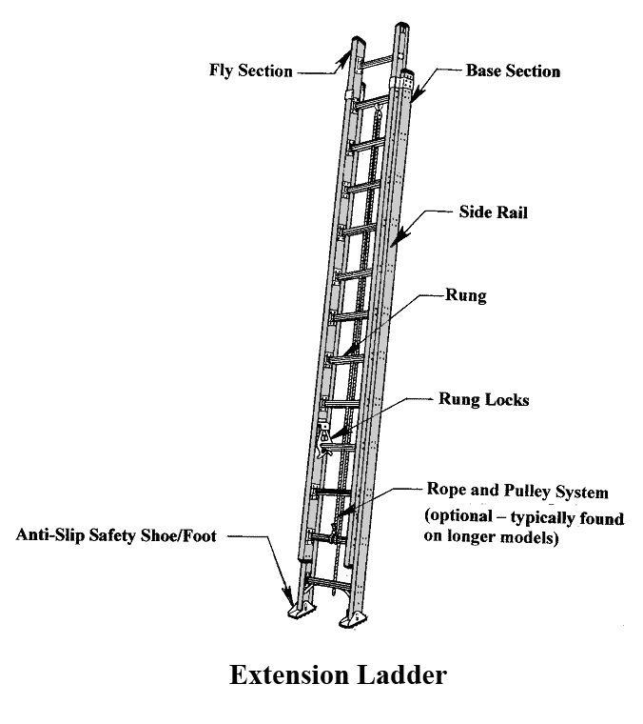

(6)

APPENDIX A

(Ladder Inspection Form)

